COMP1555 (2014/15) | Computer Algorithms and Modelling | Header ID:  219605 | Contribution:  50% of course
Coordinator:  Dr Cos Ierotheou | Release Date:  Monday 29/09/2014 |  | Deadline Date:  Tuesday 29/11/2014
This coursework should take an average student who is up-to-date with tutorial work approximately 25 hours
Learning Outcomes:
A. Select and employ appropriate data structures.
B. Formulate and solve elementary mathematical models.
C. Obtain programmatic solutions using appropriate software, including a high level programming language.
D. Describe and discuss the efficiency, complexity, accuracy and limitations of algorithms.

Plagiarism is presenting somebody else's work as your own. It includes: copying information directly from the Web or books without referencing the material; submitting joint coursework as an individual effort; copying another student's coursework; stealing coursework from another student and submitting it as your own work. Suspected plagiarism will be investigated and if found to have occurred will be dealt with according to the procedures set down by the University. Please see your student handbook for further details of what is / isn't plagiarism. Details are also on the CMS Student Intranet.
All material copied or amended from any source (e.g. internet, books) must be referenced correctly according to the reference style you are using.
Your work will be submitted for electronic plagiarism checking. Any attempt to bypass our plagiarism detection systems will be treated as a severe Assessment Offence.

Coursework Submission Requirements

An electronic copy of your work for this coursework must be fully uploaded by midnight on the Deadline Date of Saturday 29/11/2014 using the link on the coursework Teachmat page for COMP1555.

For this coursework you must submit a single Acrobat PDF document.
In general, any text in the document must not be an image (ie must not be scanned) and would normally be generated from other documents (eg MS Office using "Save As .. PDF"). More details are on the IT Support pages . An exception to this is hand written mathematical notation, but when scanning do ensure the file size is not excessive.

For this coursework you must also upload a single ZIP file containing supporting evidence.

There are limits on the file size (current values are on TeachMat and the Student Intranet).

Make sure that any files you upload are virus-free and not protected by a password or corrupted otherwise they will be treated as null submissions.

Your work will be marked online and comments on your work and a provisional grade will be available from the Coursework page on Teachmat. A news item will be posted when the comments are available, and also when the grade is available in BannerWeb.

You must NOT submit a paper copy of this coursework, or include the Banner header sheet.

Coursework Regulations

If you have Extenuating Circumstances you may submit your coursework up to two weeks after the published deadline without penalty but this is subject to acceptance of your claim by the Faculty Extenuating Circumstances Panel.

Late submissions will be dealt with in accordance with University Regulations.

Coursework submitted more than two weeks late may be given feedback but will be recorded as a non-submission regardless of any extenuating circumstances.

Do not ask the lecturers for extensions to published deadlines - they are not authorised to award an extension.

All courseworks must be submitted as above. Under no circumstances can they be accepted by academic staff.

Please refer to the University Portal for further detail regarding the University Academic Regulations concerning Extenuating Circumstances claims.

Detailed Specification

This coursework is to be done individually.

Deliverables

The implemented solution should be uploaded electronically by the deadline date. There are a number of components to the expected upload including the report and the source code. See below for details of the deliverables.

Grading Criteria
Marks will be distributed as follows:

0-30 | An unsatisfactory attempt to solving the problem.
31-39 | A substandard submission which has no critical appraisal of the concepts of data regression analysis and which contains little reporting/analysis of the results.
40-49 | An acceptable submission with reasonable understanding of the concept of data regression analysis, how to implement such a technique and a basic analysis of results.
50-59 | Work of sound quality which includes a good understanding of the concept of design, implementation and documentation together with some analysis.
60-69 | A good or very good submission that clearly demonstrates that the student knows and understands how to design, implement and document software together with some critical analysis of the results and algorithms used.
70-79 | An excellent or outstanding submission which demonstrates a clear understanding of problem solving and computer programming. Clear derivation and presentation of all necessary approaches including design, implementation, documentation and clear reporting.
80+ | A submission which demonstrates an in-depth, clear understanding of problem solving and computer programming. Exemplary derivation and presentation of all necessary approaches including design, implementation, documentation and reporting.

Assessment Criteria

The assessment comprises one question and is worth 100 marks. See below for a detailed breakdown of marks for the question.
Computer Algorithms and Modelling (COMP1555)
Coursework 2014/2015

A Regression Analysis Tool for Data Analysis and Forecasting

This coursework is to be done individually

Regression analysis is an important computation technique used in Statistics. Regression analysis helps in understanding how the typical value of the dependent variable changes when any one of the independent variables is varied, while the other independent variables are assumed to be fixed. It is also used to predict or forecast the dependent variable in the future based on past historical values of the dependent and independent variables. For example, we might want to predict the level of sales in the future for a product by studying the relationship between the sales (dependent variable) and the level of marketing (independent variable).

You have been asked by the Statistics Group in a large estate agents firm to provide them with a software application that performs linear regression analysis on a set of data for selling prices of houses. This dataset consists of the selling price which here is the dependent variable (Y) and a set of seven independent variables (X₁, X₂,…,X₇). The aim of the application is to help a user to understand the relationship between the selling price of a house and parameters such as the number of rooms, age of the house, floor size of the property and garden, etc. Additionally, the user should be able to use this application to forecast the selling price of a house given a certain no. of rooms, the age of a house and so on. The application should allow the user to select the independent variable (X_{i}) from a list of possible variables and then, perform a regression analysis using the dependent variable, Y (selling price) and the selected independent variable X_{i}.

The application will provide the following functionality through a GUI:
- Selection of independent variable, X_{i} to be used for regression analysis.
- Plotting the scatter diagram of the (X_{i},Y) value pairs (e.g. see figure A below).
- Calculation of the statistical information (e.g. see Tables A-D below).
- Graphical representation of the least squares regression line of Y on X_{i} (e.g. see figure B)
- Forecasting of the dependent variable in the future (i.e predict Y given a value for X_{i}, e.g. see Table E below)
- Graphical representation of the forecasted values (e.g. see figure B)
- User selected option to determine in ascending order which independent variable, X_{i} provides the highest correlation with the dependent variable, Y (e.g. expansion of Table D below).

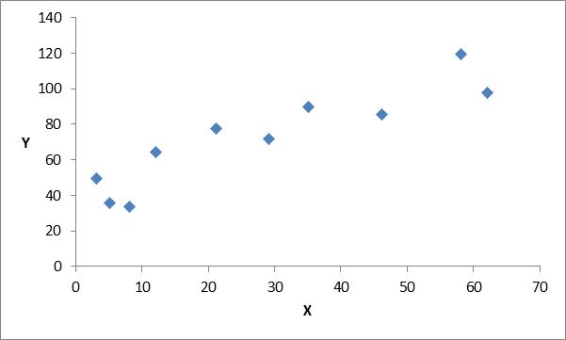
Figure A: Scatter diagram of (X,Y)
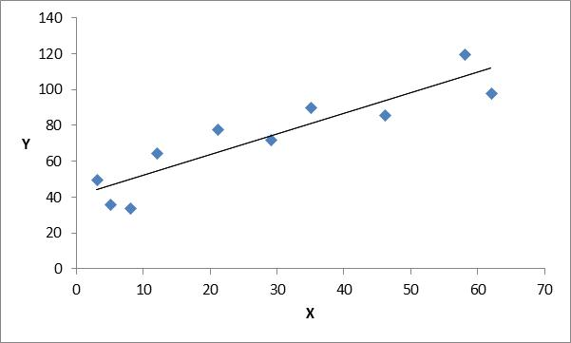
Figure B: Forecast line

Y | X_{i}
Table A: Input data (X,Y)

 | X | Y
N
Mean
Variance
Std. Dev.
Table B: Data Summary (i)

∑X
∑X²
∑Y
∑Y²
∑XY
Table C: Data Summary (ii)

R | R² | Slope | Y Intercept | Std. Err. of Estimate
Table D: Linear Regression Analysis Results

X | Forecasted Y
Table E: Forecast Values

In your solution you need to pay attention to the ease-of-use of the Java program that you write, so that
- the data can be input in various ways (in an input file or directly through the keyboard)
- tabular and graphical representation of data and results are provided as appropriate
- A simple, clear and consistent GUI that allows the user to initiate and control all the actions and provides feedback where appropriate.

Deliverables:
Deliverable 1 – the report in PDF format
Your report should contain:
Design and user documentation of how to use the program 10%
Test methodology and evidence 10%
Analysis of results for the test data you provide 10%
Critical evaluation of application to include data structures, algorithms
and performance 10%
Conclusions 10%

Deliverable 2 – the well commented JAVA source code
The correctly functioning Java source code should be uploaded as a zip file 35%
Viva demonstration of your working solution (schedule TBC) 15%

The dataset to be used is the following:

 | Y | X₁ | X₂ | X₃ | X₄ | X₅ | X₆ | X₇
1 | 4.9176 | 1.0 | 3.472 | 0.998 | 1.0 | 7 | 4 | 42
2 | 5.0208 | 1.0 | 3.531 | 1.5 | 2.0 | 7 | 4 | 62
3 | 4.5429 | 1.0 | 2.275 | 1.175 | 1.0 | 6 | 3 | 40
4 | 4.5573 | 1.0 | 4.050 | 1.232 | 1.0 | 6 | 3 | 54
5 | 5.0597 | 1.0 | 4.455 | 1.121 | 1.0 | 6 | 3 | 42
6 | 3.8910 | 1.0 | 4.455 | 0.988 | 1.0 | 7 | 3 | 56
7 | 5.8980 | 1.0 | 5.850 | 1.240 | 1.0 | 7 | 3 | 51
8 | 5.6039 | 1.0 | 9.520 | 1.501 | 0.0 | 6 | 3 | 32
9 | 16.4202 | 2.5 | 9.800 | 3.420 | 2.0 | 10 | 5 | 42
10 | 14.4598 | 2.5 | 12.80 | 3.000 | 2.0 | 9 | 5 | 14
11 | 5.8282 | 1.0 | 6.435 | 1.225 | 2.0 | 6 | 3 | 32
12 | 5.3003 | 1.0 | 4.988 | 1.552 | 1.0 | 6 | 3 | 30
13 | 6.2712 | 1.0 | 5.520 | 0.975 | 1.0 | 5 | 2 | 30
14 | 5.9592 | 1.0 | 6.666 | 1.121 | 2.0 | 6 | 3 | 32
15 | 5.0500 | 1.0 | 5.000 | 1.020 | 0.0 | 5 | 2 | 46
16 | 5.6039 | 1.0 | 9.520 | 1.501 | 0.0 | 6 | 3 | 32
17 | 8.2464 | 1.5 | 5.150 | 1.664 | 2.0 | 8 | 4 | 50
18 | 6.6969 | 1.5 | 6.902 | 1.488 | 1.5 | 7 | 3 | 22
19 | 7.7841 | 1.5 | 7.102 | 1.376 | 1.0 | 6 | 3 | 17
20 | 9.0384 | 1.0 | 7.800 | 1.500 | 1.5 | 7 | 3 | 23
21 | 5.9894 | 1.0 | 5.520 | 1.256 | 2.0 | 6 | 3 | 40
22 | 7.5422 | 1.5 | 4.000 | 1.690 | 1.0 | 6 | 3 | 22
23 | 8.7951 | 1.5 | 9.890 | 1.820 | 2.0 | 8 | 4 | 50
24 | 6.0931 | 1.5 | 6.726 | 1.652 | 1.0 | 6 | 3 | 44
25 | 8.3607 | 1.5 | 9.150 | 1.777 | 2.0 | 8 | 4 | 48
26 | 8.1400 | 3 | 8.000 | 1.504 | 2.0 | 7 | 3 | 3
27 | 9.1416 | 1.5 | 7.326 | 1.831 | 1.5 | 8 | 4 | 31
28 | 12.0000 | 1.5 | 5.000 | 1.200 | 2.0 | 6 | 3 | 30

Table Legend :-

Y: Selling Price (£100 000’s)
X₁: No. of bathrooms
X₂: Area of the site (1000’s square feet)
X₃: Size of living space (1000’s square feet)
X₄: No. of garages
X₅: No. of rooms
X₆: No. of bedrooms
X₇: Age (years)

If you are unsure about any of these instructions then please email the course leader with your query or make an appointment to see the course coordinator as soon as possible.

This dataset has been adapted from online resource for linear regression datasets. Website: http://orion.math.iastate.edu/burkardt/data/regression/regression.html

